An AI system can be developed with these three

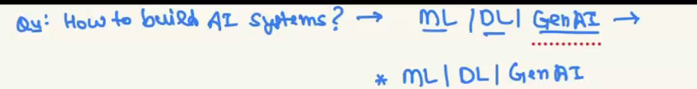

Overfitting and underfitting are analyzed in model evaluation phase

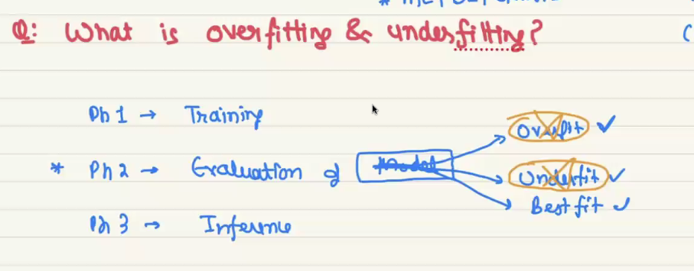

Underfitting is a problem in building ml model, it Is occurred when model doesn’t have enough good data to learn and predict.

When a model gives very low accuracy in evaluation phase then the model will be called as underfitted model.

We can also say that a model doesn’t learn well to make prediction, if a model is not make good prediction then directly we can say that model doesn’t have enough data to learn and that is called underfitting.

Overfitting also occurs when the model doesn’t learn the needed data instead of learning common patterns in all training samples it learns other things which is not needed to make prediction.

In training phase the model is return 90 in evaluation model is return very low accuracy then it is called overfitting.

Below image will gives you the example of when will the model is called over and under fitting

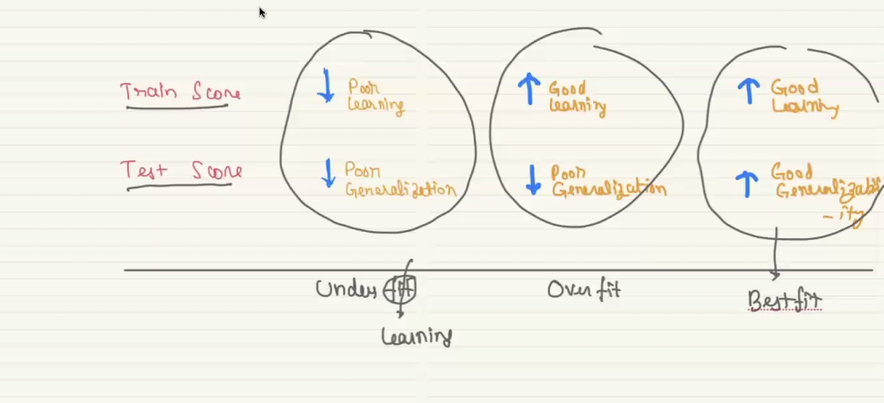

3. overfit

1. underfit

2. best fit

In the below image

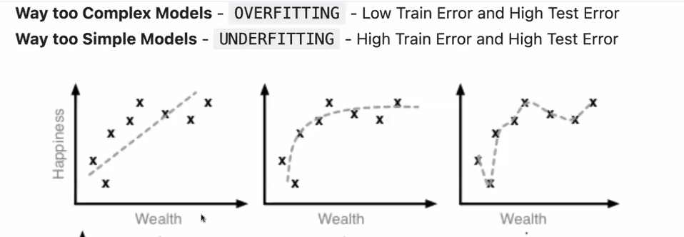

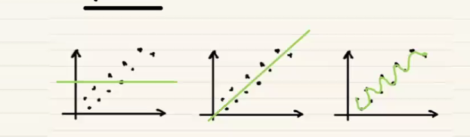

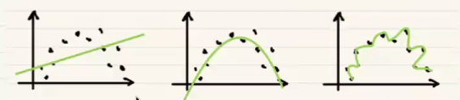

Below image is the example of over and under fit in categorical data (classidficatio), while above if for regression problem

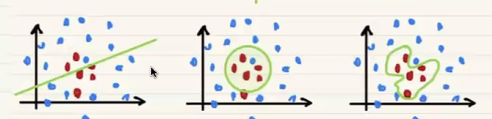

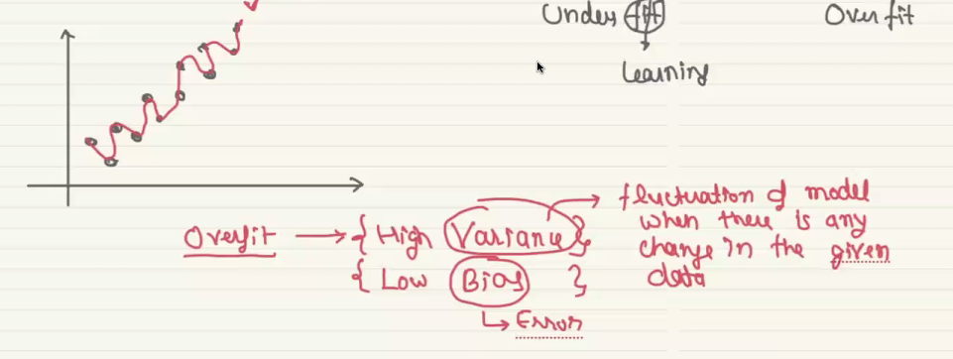

Variance describes how model changes it’s performance when given data is changed, example in below image

